MASAK Compliance for Log360
Tagline: Meet MASAK reporting obligations with centralized log monitoring from Log360.

Overview
The MASAK (Turkish Financial Crimes Investigation Board) Compliance extension for Log360 helps Turkish obligated entities — including banks, payment institutions, and virtual asset service providers — meet the IT-related access control, audit logging, and transaction monitoring requirements under MASAK AML/CFT regulations.
Log360 collects and correlates logs from financial systems, transaction platforms, cloud environments, and identity services, providing compliance teams with visibility into access events and anomalous behavior relevant to financial crime risks. Teams can investigate suspicious activities and generate documentation for MASAK disclosures.

Key Features
- Generate compliance reports covering MASAK-relevant IT controls including access to financial records, user authentication logs, and transaction system monitoring.
- Monitor financial system access and detect unusual data queries, exports, or privileged actions that may indicate financial crime facilitation.
- Configure real-time alerts for AML/CFT-relevant security events such as unauthorized access to customer financial data and suspicious privilege escalations.
- Export audit evidence in PDF and CSV formats for MASAK reporting, internal AML compliance officer records, and supervisory authority submissions.
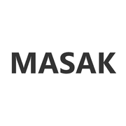
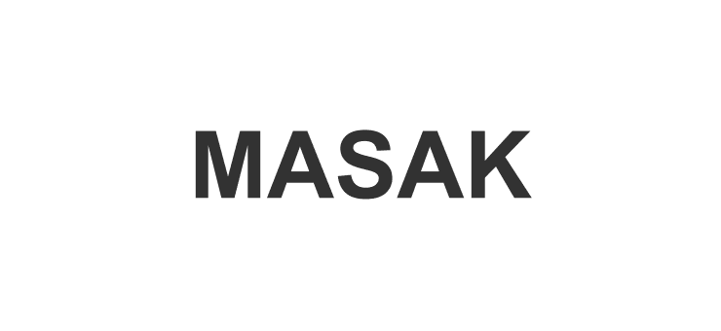

Screenshots
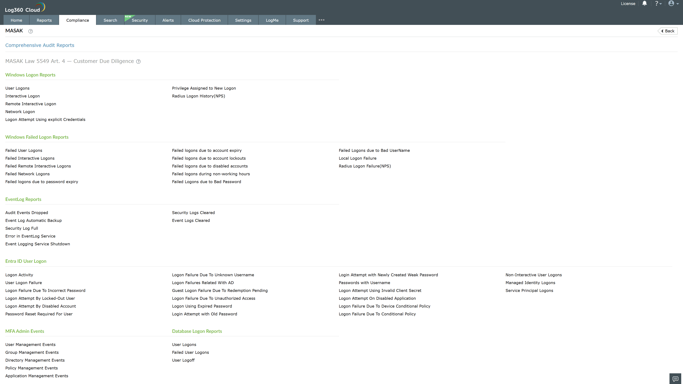
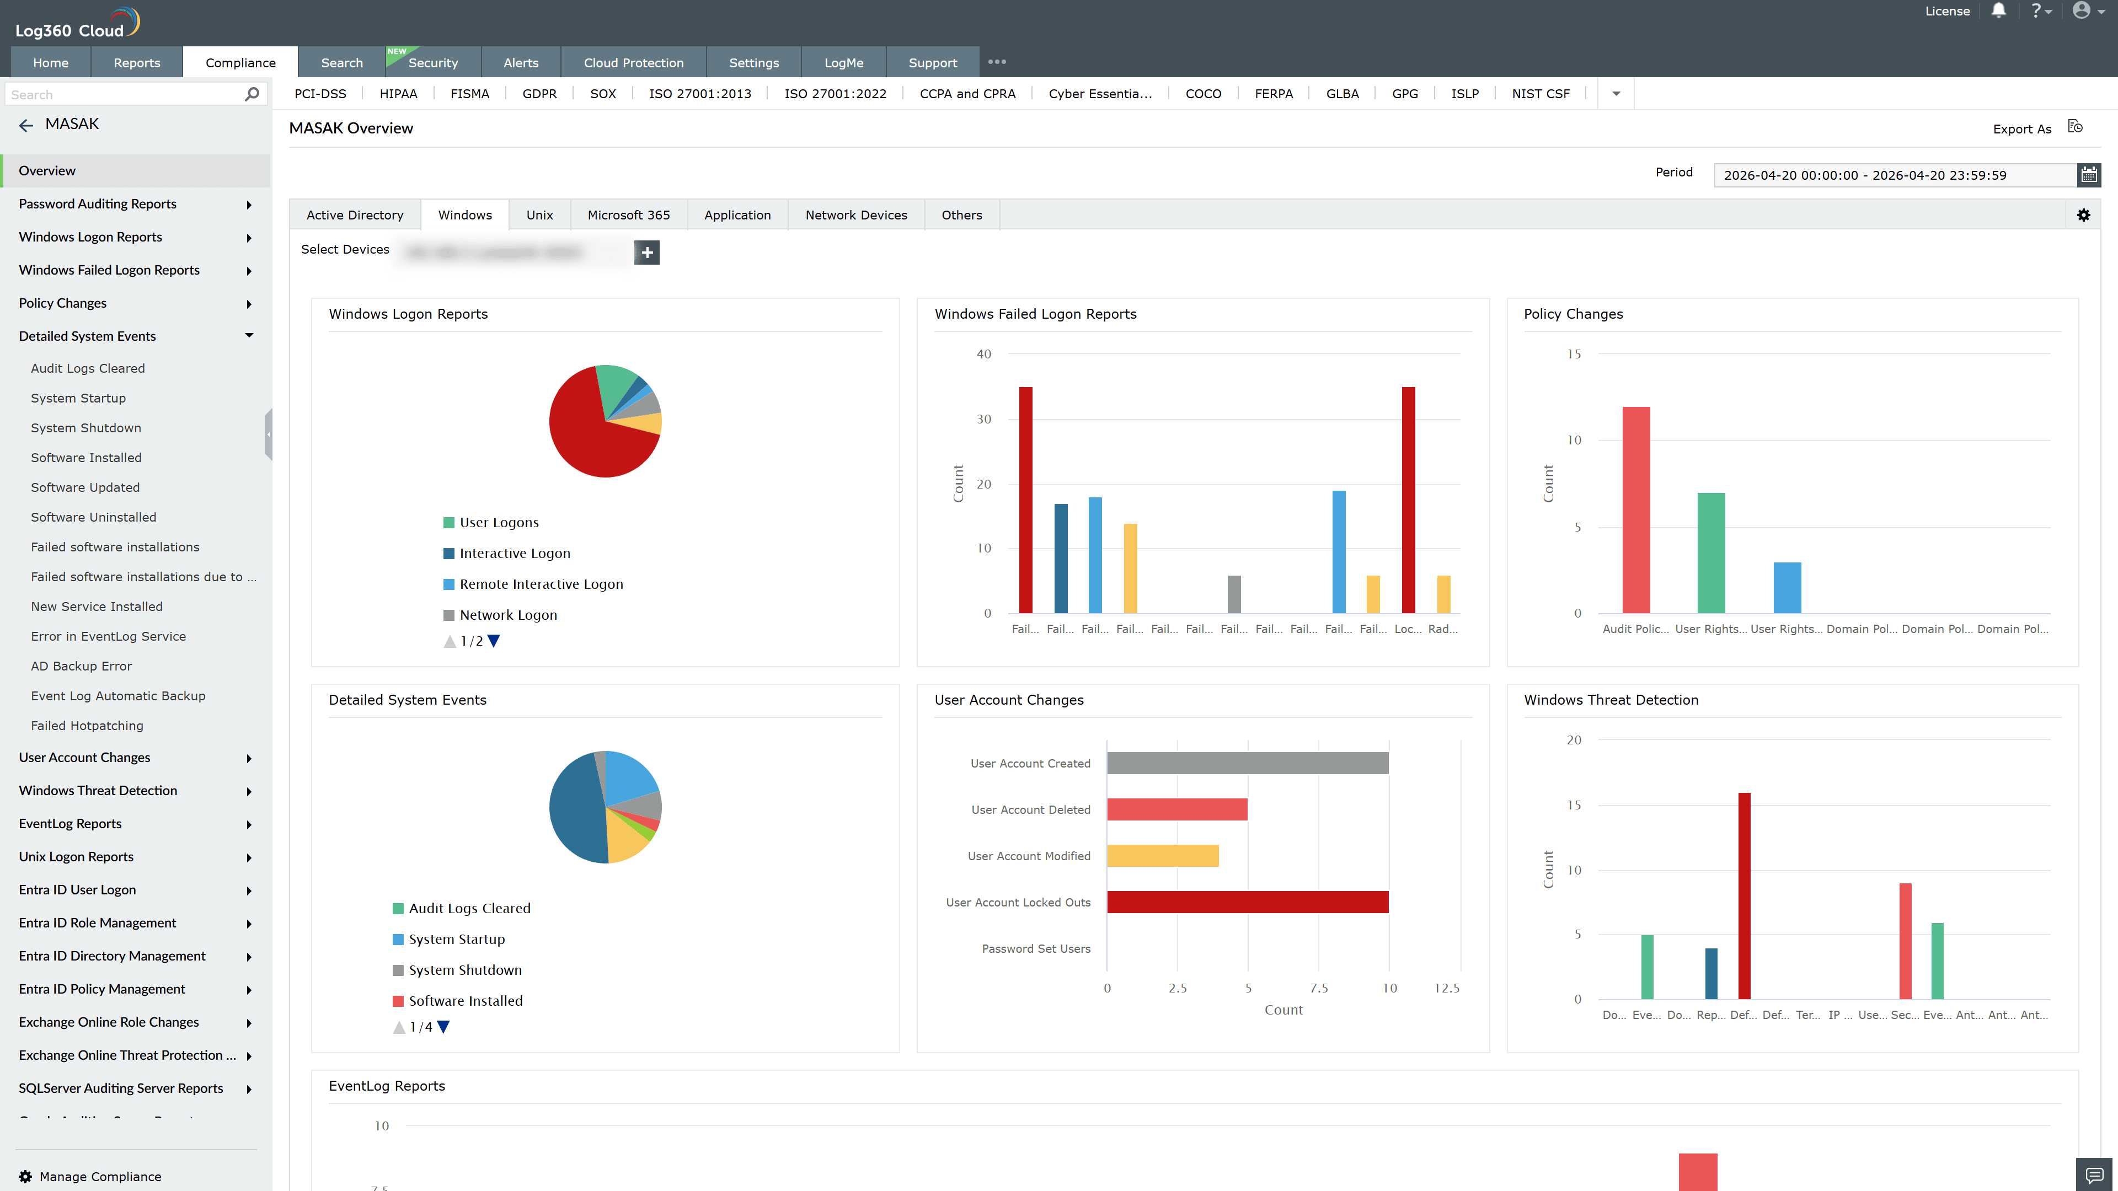
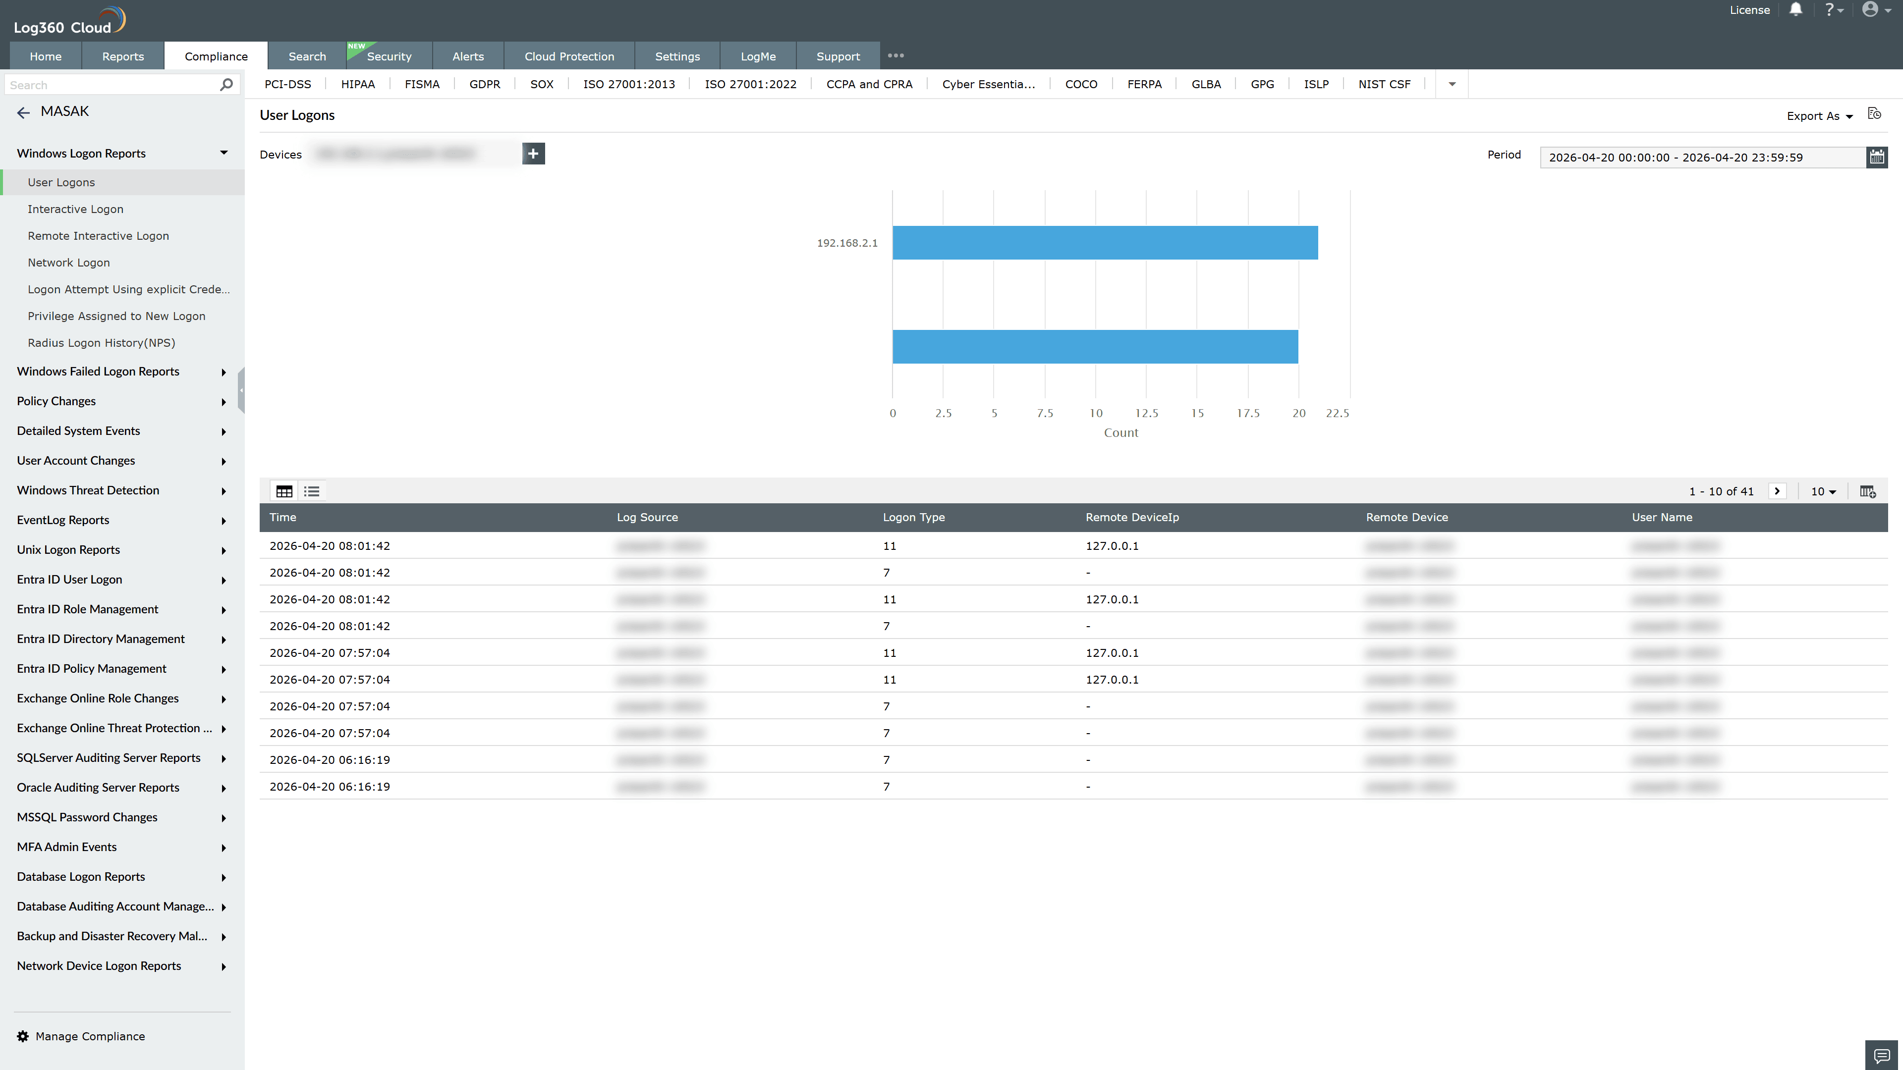
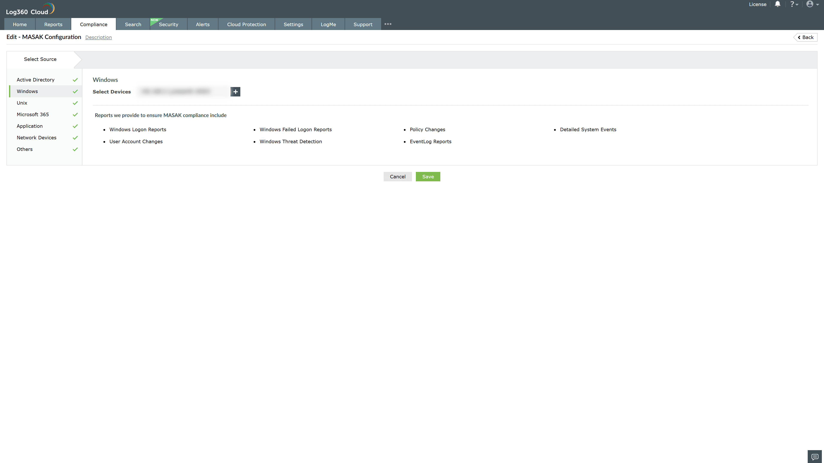

Valid Submission : Yes
Supported Editions : Free, Basic, Standard, Professional, MSSP
Help Document : https://www.manageengine.com/log-management/help/integrations/compliance-extensions.html
Help Video : Not provided
Tags : Log360, Compliance, Privacy monitoring, Data privacy, Regulatory compliance
Supported DCs : US, IN, JP, CA, AU, UK and EU
Privacy Policy:
Terms of Service:
Release Notes:
Predefined reports for the MASAK Compliance

